New Student Guide to account access for myReinhardt and EagleWeb

- Go to www.reinhardt.edu


- Click on “myReinahrdt”

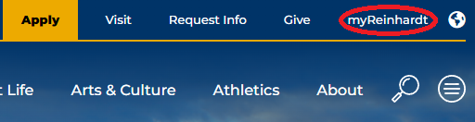

- Type in your Reinhardt student email
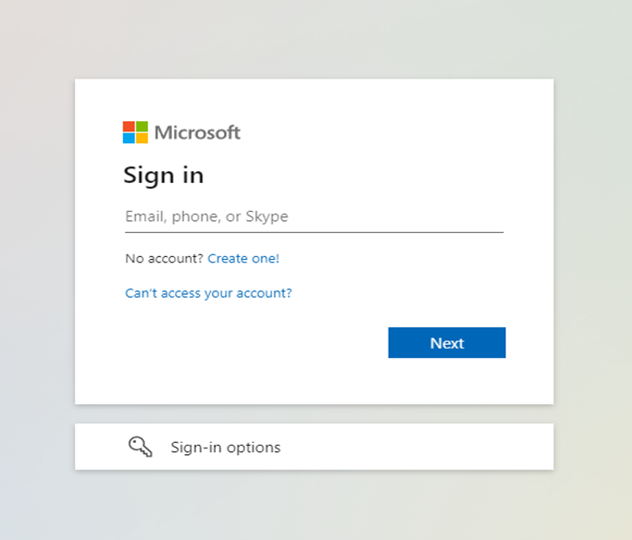

- Type in “welcometoreinhardt” for the password 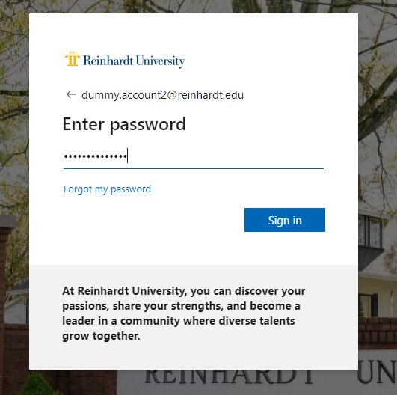

- Click “next” on the “More information required”
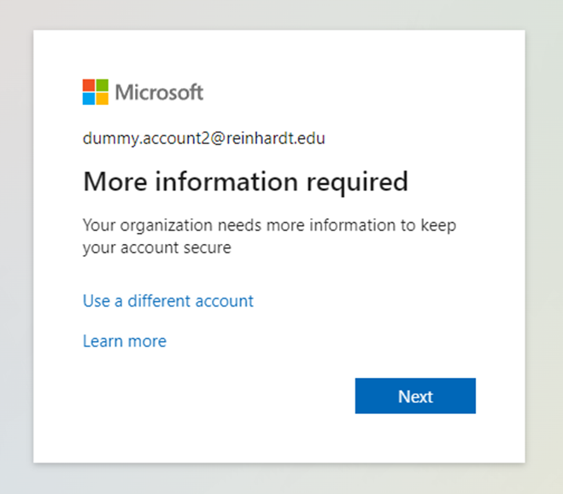

- Download “Microsoft Authenticator” app on a cell phone
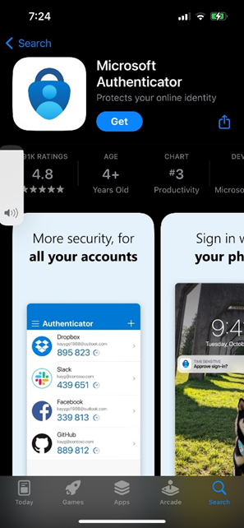

- Once the app is downloaded click “next”
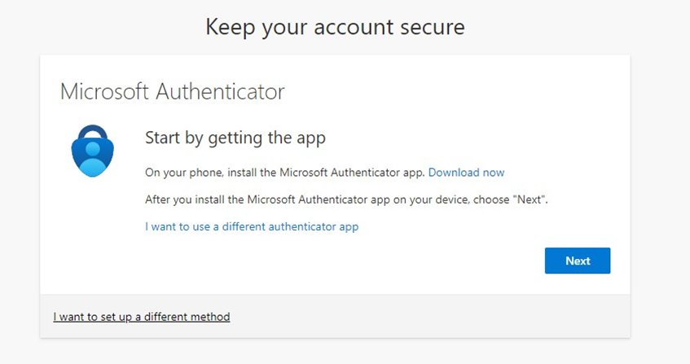

- Click “next”
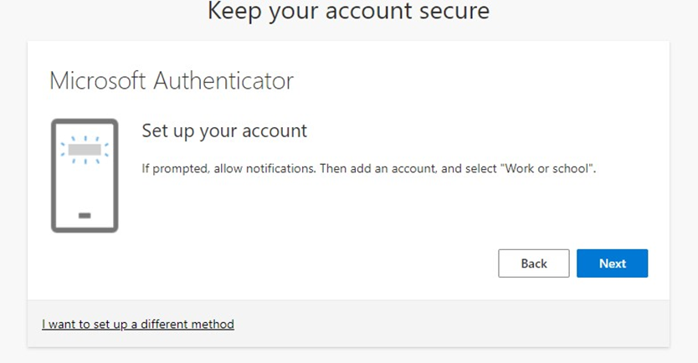

- Scan the QR code with the Microsoft Authenticator App, then click “next”
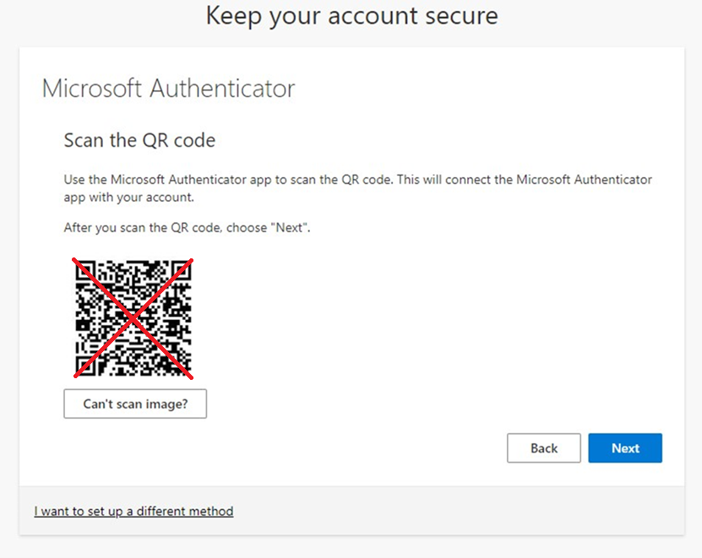

- Enter the number code from the website on to the authentication app
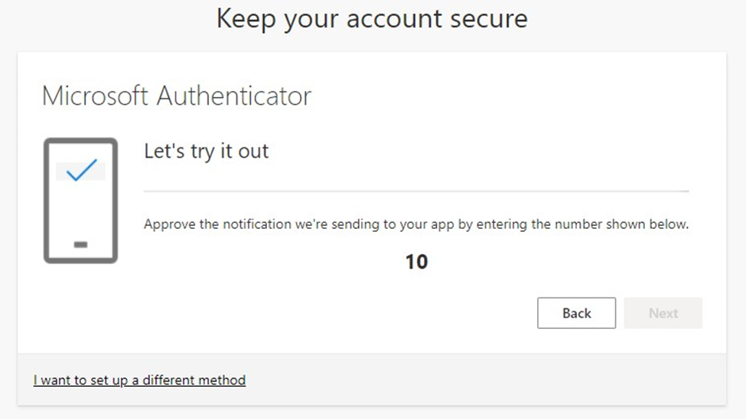

- When completed the below screen will show, then click “next”
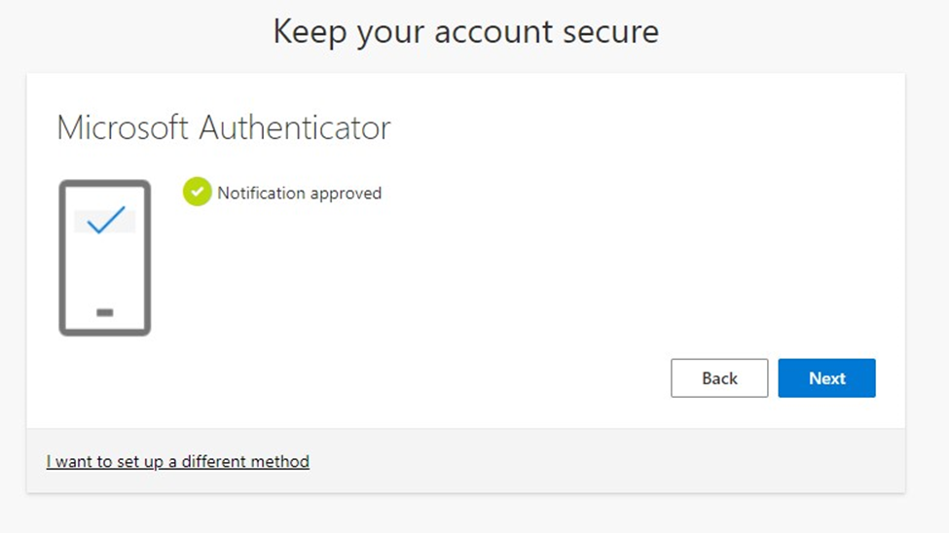

- Click “Done”
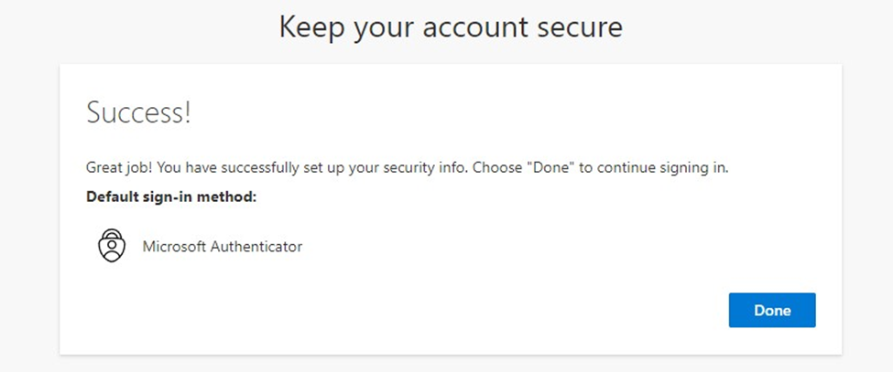

- After clicking done, on the next screen you will be forced to change your password. This is so you can set up your passphrase that is different from everyone else.

- On this screen input the current password (welcometoreinhardt) then enter your new passphrase (minimum 14 characters)
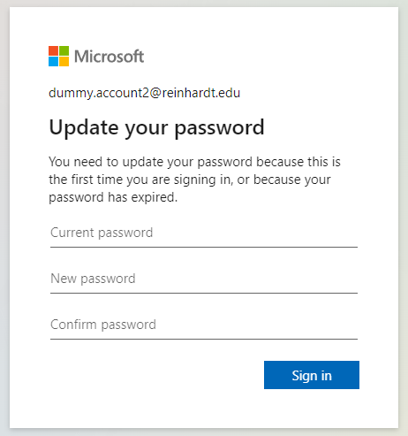

- When this screen comes up, close the tab and follow Steps 1 & 2 again
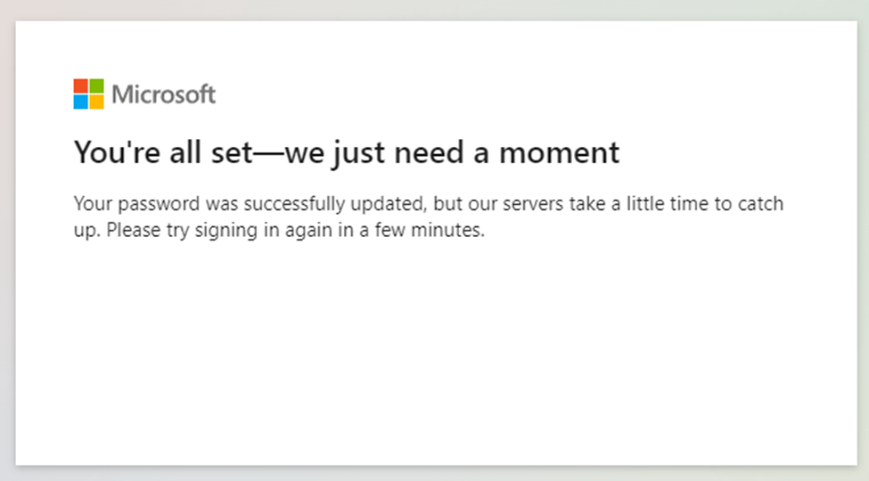

- Sign in with your Reinhard student email

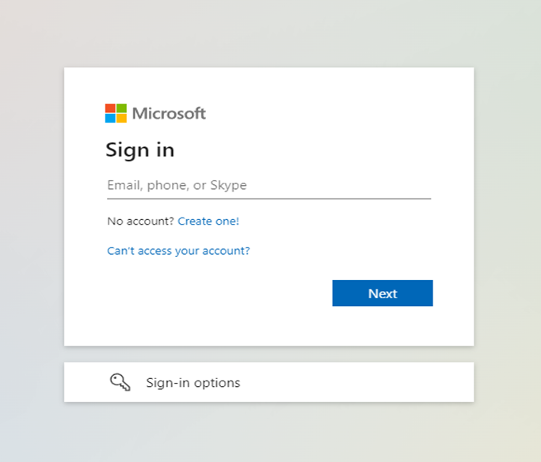

- Enter your new minimum 14 character password
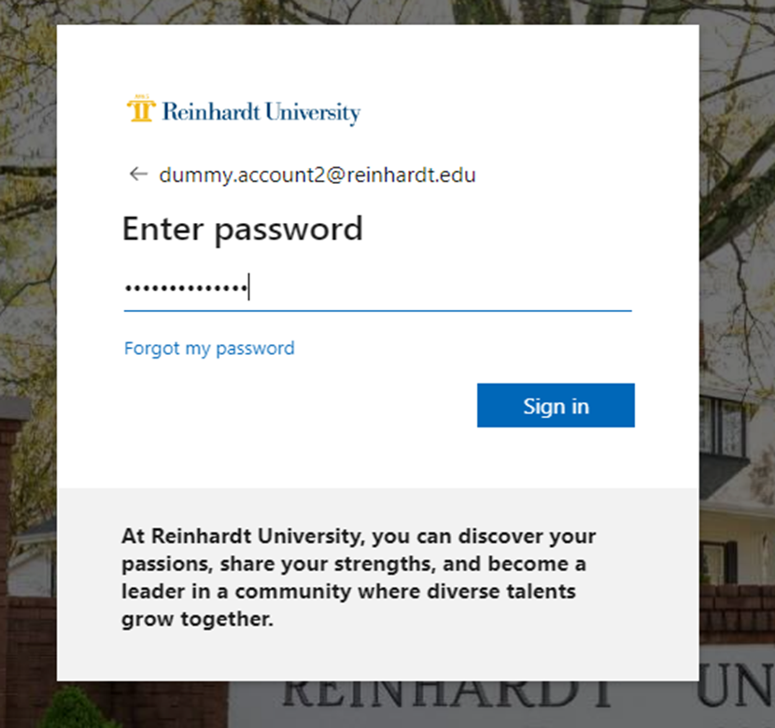

- Type in the number that pops up on the screen on the “Microsoft Authenticator” App
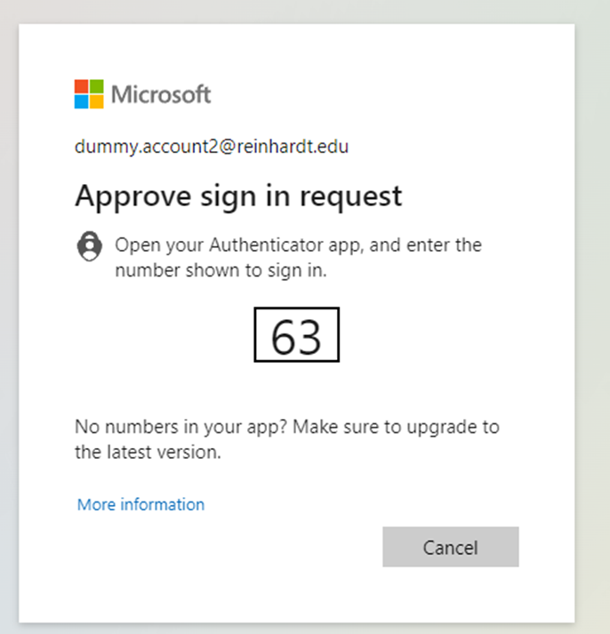

- Click “don’t show this again” and click “no” 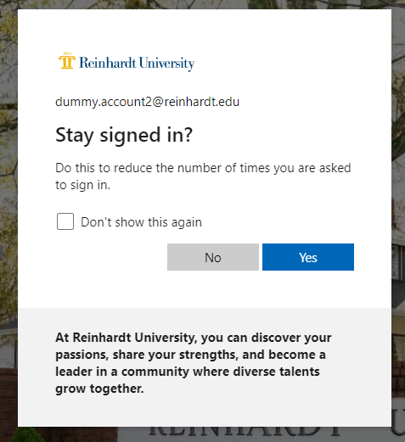

- Once completed you will see your app page
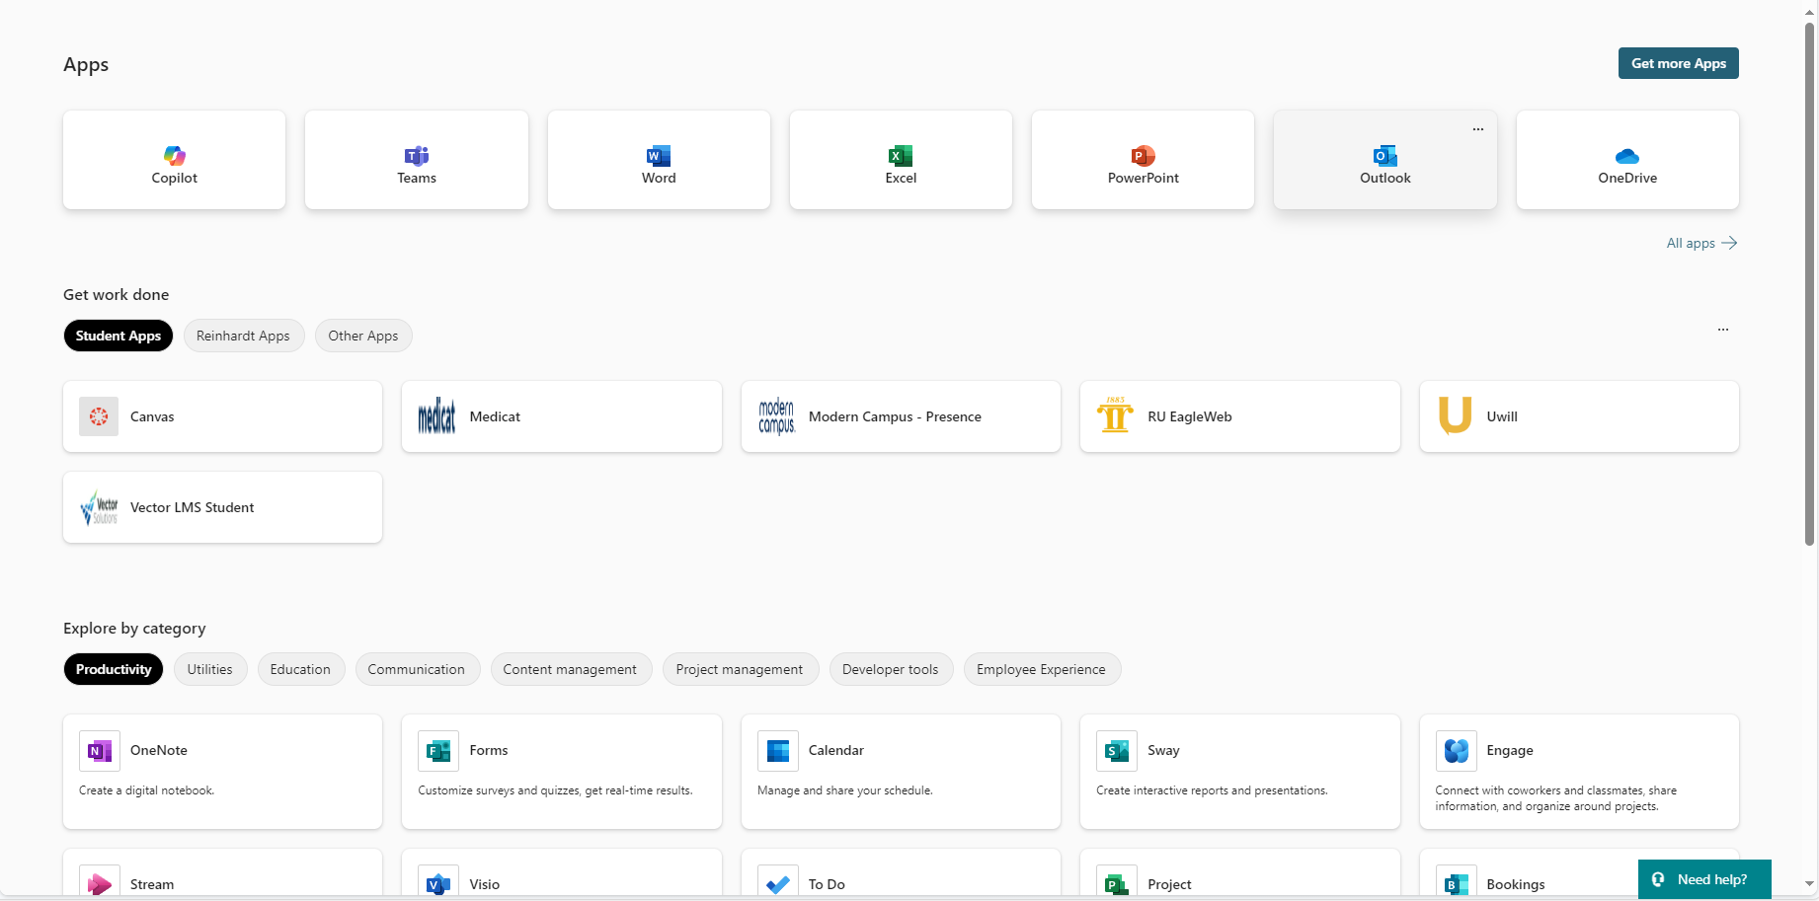

- Here you can access Canvas, Medicat, EagleWeb, Outlook, Vector, Etc.

- EagleWeb utilizes a different authentication system so that a unique username and password from each student . Follow the steps below for first time password set up. Click on the “RU EagleWeb” app to access EagleWeb

- In the Username field type your Student ID number

- Click “I forgot my password”

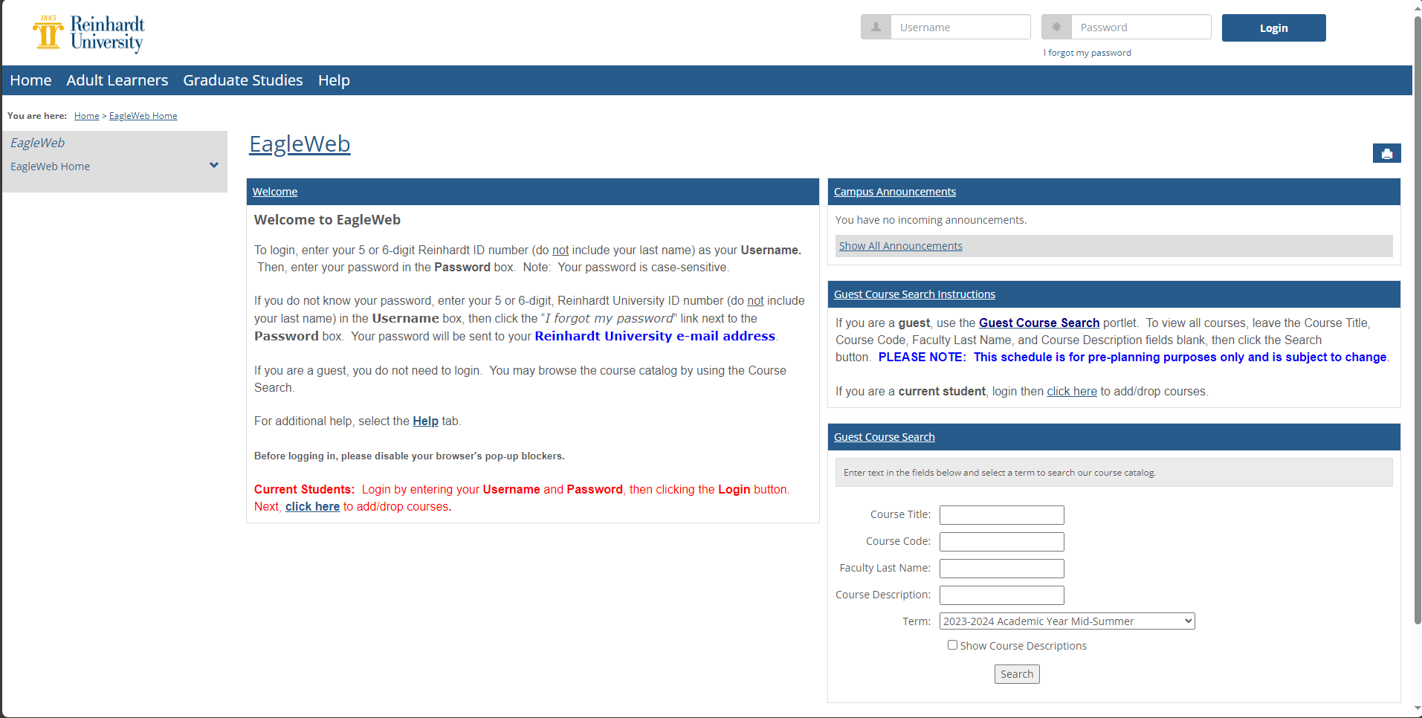

- In the email field type in your Student email (lastnameIDnumber@students.reinhardt.edu) 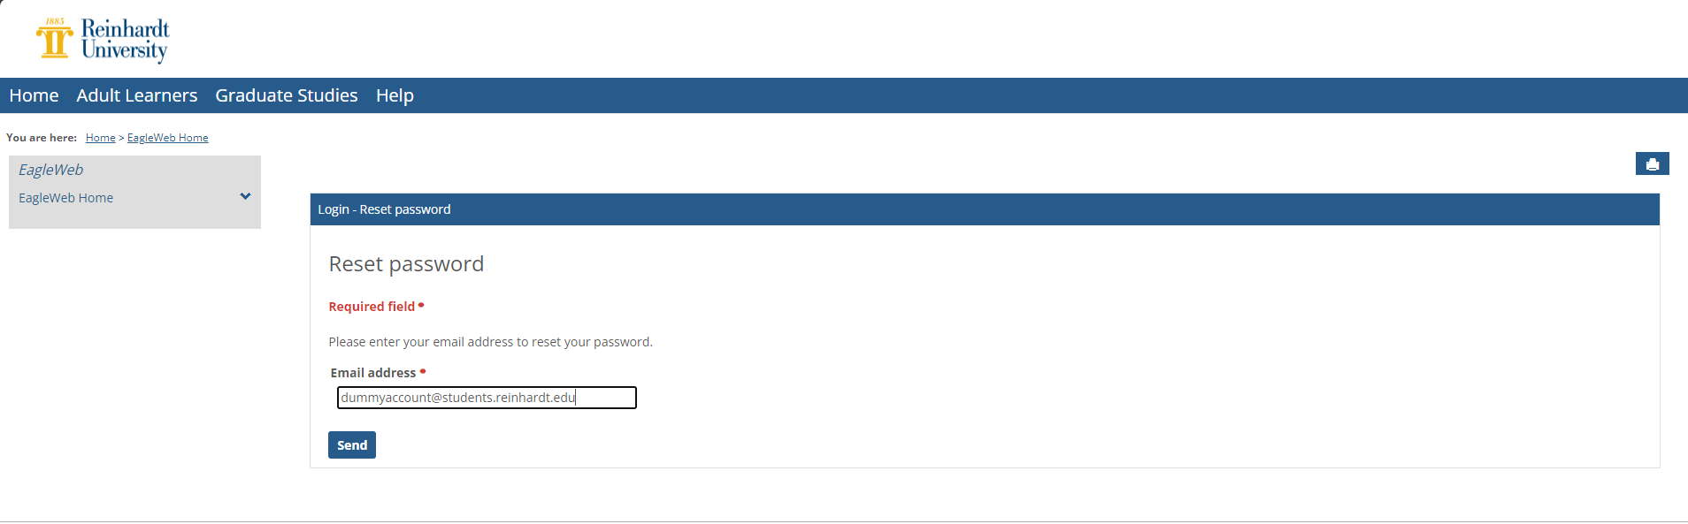

- Click “Send”

- After 5 minutes you will receive an email in your student email, open the email then click the link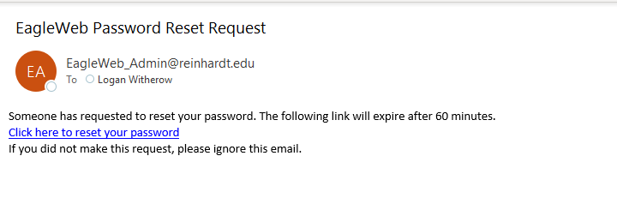

- On the new page create your new password between 4 – 10 characters (anything under or over will not be accepted)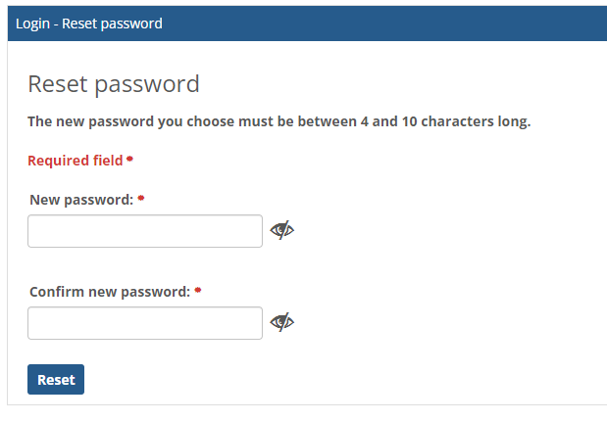

- Click “reset” when the new password has been typed in

- Login with the ID username and the newly created password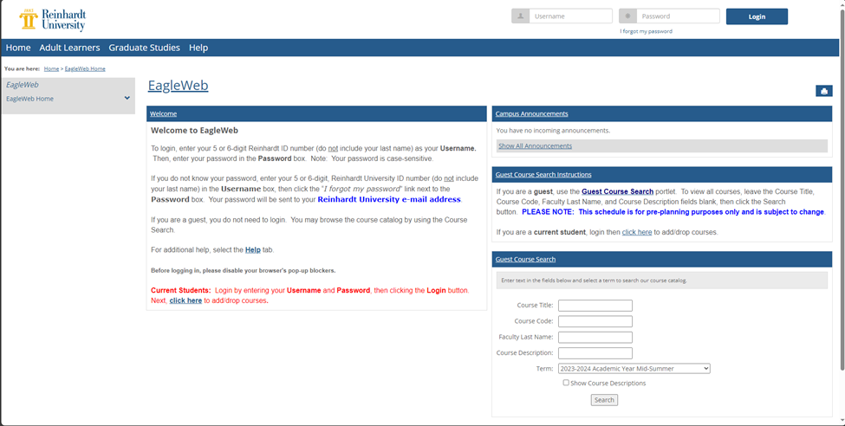

- When successful, the screen will look like the image below

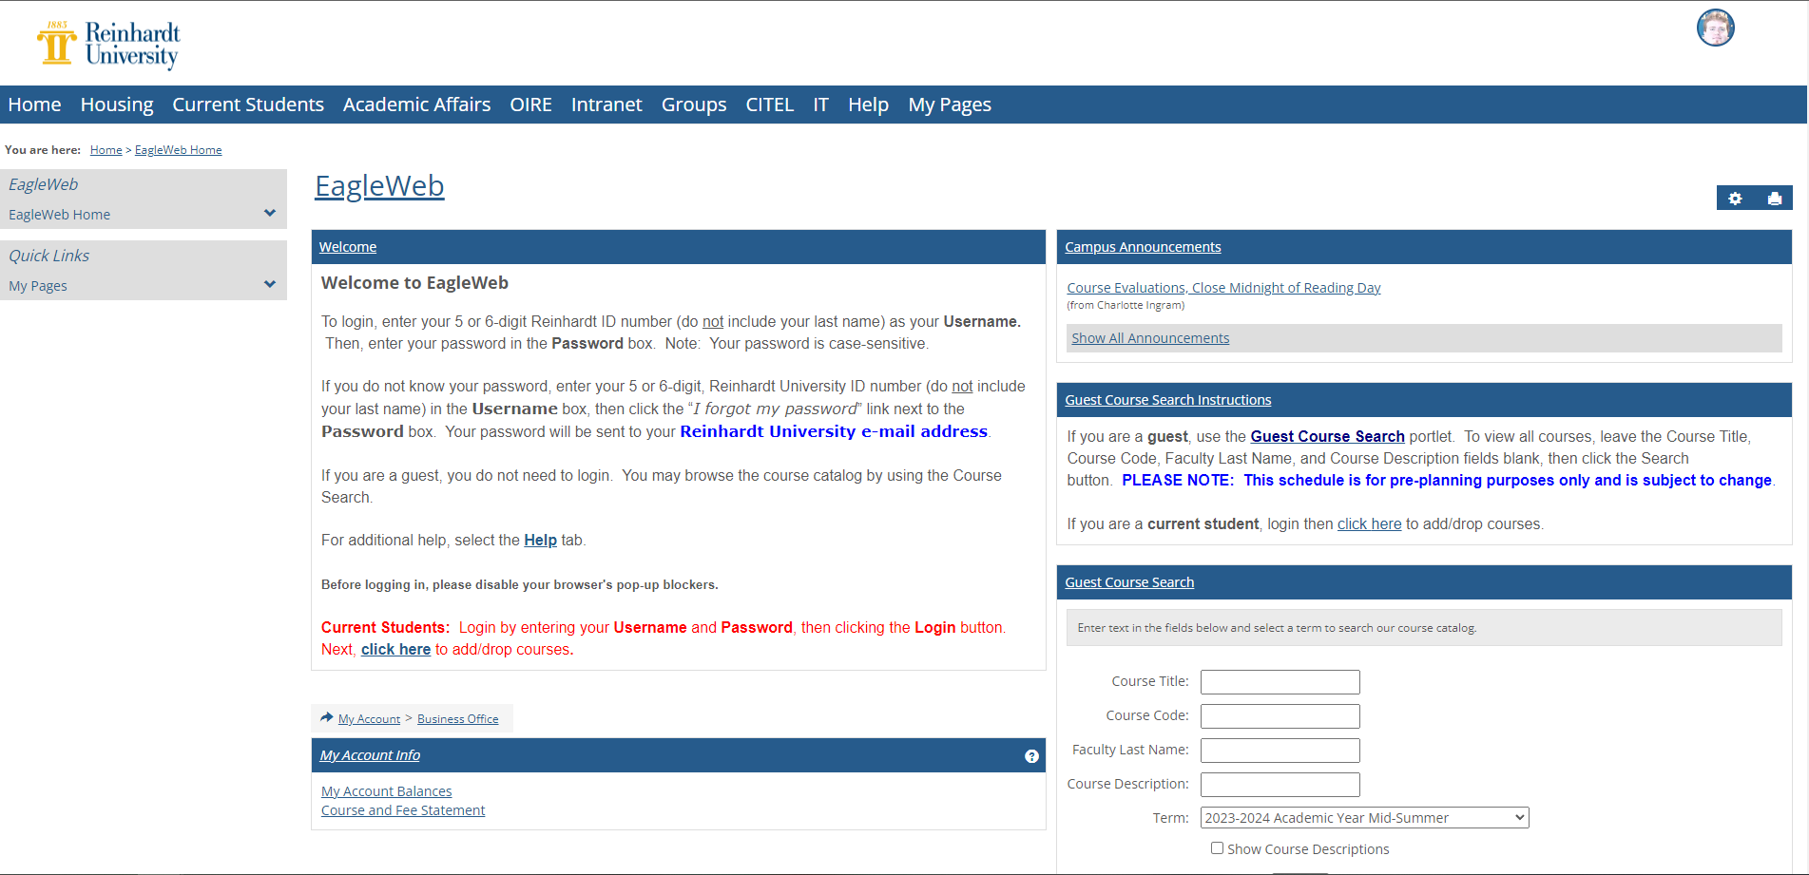

- Now you have access to your myReinhardt portal and EagleWeb portal

